MULANJE CLUSTER MOCK EXAMINATION

2022 MALAWI SCHOOL CERTIFICATE MOCK EXAMINATION
MATHEMATICS PAPER II
Friday, May 27th Time Allowed: 2 hours 30 mins
Section A (60 marks)
Instructions:
- Answer all questions in this section

- a. Simplify $\frac{y - 2}{y^{2}-3y+2}$ ÷ $\frac{y }{y-1}$ (4 marks)

b. A triangle has a height of 3cm and its area is 6cm². Calculate the area of a similar triangle with a height of 12cm. (4 marks)

- a. Figure below shows a speed-time graph of a motion

V
Speed m/s

0 10 50 60
Time (s)
If the acceleration during the first 10 seconds is 1.4$mls$². Calculate the total distance covered by the object. (6 marks)

b. Solve the equation $\log_{5}{x}$ = 1 – $\log_{5}{(x-4) }$ (5 marks)

- a. Solve the following simultaneous equations (7 marks)
9$x^{2}$ – $y$ $=$ 15
$$3x-y=5$$

b. Prove that angle subtended by arc at the centre is twice the angle subtended by the same arc at any circumference of the circle (7 marks)

- 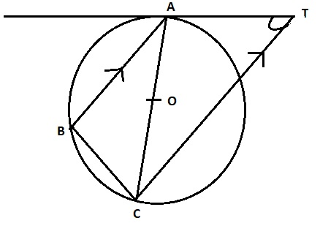a. Figure below shows a tangent AT to a circle ABC with centre O at A. Line CT is parallel to line BA and angle ATC = 32º.
32⁰

Calculate angle ACB (5 marks)

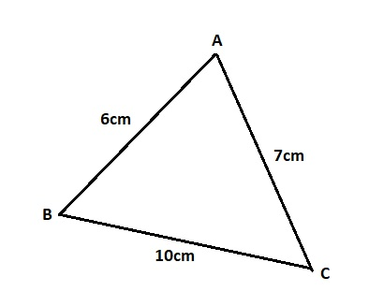b. Figure below shows a triangle ABC such that AB = 6cm, BC = 10cm and AC = 7cm

Calculate angle ACB to the nearest degree (5 marks)

- 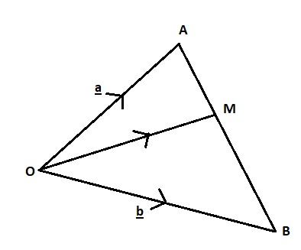a. In figure below $\vec{OA}$ =$a$ $\vec{ OB}$ = $b$ and $\vec{AM}$ = ¼ $\vec{AB}$

Find $\vec{OM}$ in terms of $a$ and $b$ (5 marks)

b. using a ruler and a pair of compasses only. Construct in the same diagram:
- A circle centre O and diameter 7cm
- A point T outside the circle such that OT = 8cm
- Tangents AT and BT at A and B respectively (6 marks)

- For Chikondi to be offered a place at a certain college, he must pass both subjects; Mathematics and Physics. Chikondi has a probability of passing Mathematics 0.8. If he passed Mathematics he has a probability of failing Physics 0.4 and if he failed Mathematics he has a probability of passing Physics 0.49. Using a tree diagram to find the probability that Chikondi did not get the place at the college. (6 marks)

SECTION B (40 MARKS)
Instruction: Answer any four questions
- A Geometric progression with a positive common ratio is such that the sum of the first two terms is 8 and the third term is 18. Find the fourth term (10 marks)

- 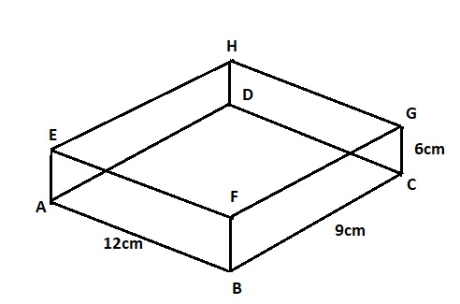Figure below shows a rectangular water tank

Calculate: a. the length of AG to 1 decimal place

b. the angle between a base ABCD and the line AG to the nearest degree (10 marks)

- Table below shows masses in kg of 40 students
59 | 54 | 51 | 56 | 61 | 59 | 60 | 57
60 | 58 | 62 | 58 | 60 | 58 | 49 | 61
59 | 52 | 60 | 61 | 64 | 56 | 57 | 58
54 | 60 | 58 | 69 | 63 | 58 | 51 | 63
56 | 60 | 62 | 67 | 65 | 70 | 69 | 57

- Using data in table above and taking intervals of 46-50, 51-55… construct a frequency distribution table for the data

- Using a scale of 2cm to represent 5units on the vertical axis and 2cm to represent a class on the horizontal axis, draw a frequency polygon for the data (10 marks)

- Solve the equation $x^{3}$ + $x^{2}$ - 9$x$ – 9 = 0 (10 marks)

- A businesswoman wants to buy up to 500 skirts for her shop. She has K9000 to spend. There are two types of skirts available, one type costing K30 each and the other costing K10 each. She wants to buy at least 100 of each type of skirts.
- If $x$ represents the number of experiment type of skirts and $y$ represents the number of cheaper type of skirts, write down four inequalities that satisfy the given information. (3 marks)

- Using a scale of 2cm to represent 100 units on both axes, draw graphs to show the region bounded by four inequalities, and shade the unwanted region. (5 marks)
- Using the graphs, find the maximum number of each type of skirts he should buy in order to maximize profit if the profit is K10 each on the expensive skirts and K5 each on the cheaper skirts.(2 marks)

- The table below shows some values of $x$ and $y$ for the equation $y$ = $x^{3}$- 3$x$
$$x$$ | -3 | -2 | -1 | 0 | 1 | 2 | 3
$$y$$ | -18 | -2 |  | 0 |  | 2 | 18

- Complete the table of values (2 marks)

- Using a scale of 2cm to represent 1 unit on the horizontal axis and 2cm to represent 5units on the vertical axis. Draw the graph of $y$ = $x^{3}$- 3$x$ (5 marks)
- Use your graph to solve the equation: $x^{3}$- 5$x$ + 2 = 0 (3 marks)

END OF QUESTION PAPER

